**Wanderlust: A Personalized Travel Planning And Tracking App**

**Course Name** : NAANMUDHALVAN ,

**Department** : COMPUTER SCIENCE AND ENGINEERING,

**Year & Sem**  : 3rd and 5th ,

**Regulations** : R2021,

**Academic Year** : 2024-2025,

**Date of Submission** : 15/11/2024.

**812022104001 - Aadhithya.S,**

**812022104002 -Aathikesavan.S,**

**812022104005-Anbumani.k,**

**812022104011-Ashok.R.**

**Submitted by,**

**Abstraction**

Wanderlust is a personalized travel planning and tracking app that offers users a streamlined way to plan, organize, and track their travel experiences. In response to the growing demand for customized travel solutions, Wanderlust combines itinerary management, budget tracking, real-time updates, and tailored recommendations in a single platform. This report examines the app’s key features, technological foundation, market fit, and potential for growth, detailing how Wanderlust addresses gaps in existing travel apps. By providing a complete view of its functionalities, user experience, and development process, this report highlights Wanderlust’s unique value in enhancing modern travel planning and engagement.

**Introduction**

The Wanderlust app is a comprehensive, personalized travel planning and tracking tool designed to simplify the travel experience for users. With a rapidly growing global interest in travel, travelers are increasingly seeking intuitive, customized solutions to help them navigate everything from initial planning to real-time tracking while on their journey. Wanderlust meets this demand by offering a platform that consolidates key travel elements, including itinerary management, budget tracking, real-time updates, and recommendations tailored to individual preferences. This report aims to provide an in-depth overview of Wanderlust’s features, technology, and market positioning, highlighting how the app addresses gaps in the current travel app market. By examining the app's capabilities and development process, this report underscores how Wanderlust is uniquely positioned to meet the needs of today’s travelers, from solo adventurers to families. It also explores potential monetization strategies, user feedback, and future plans, offering a complete picture of Wanderlust's role in the evolving landscape of travel technology. The following sections will delve into the app's core functionalities, user interface, and competitive advantages, emphasizing how Wanderlust brings personalized travel planning into the digital age.

**App Features and Functionality**

Wanderlust offers an array of powerful features designed to streamline and personalize the travel experience from start to finish. Below are the key functionalities that make the app a comprehensive tool for travel planning and tracking:

**Personalized Travel Planning**

Wanderlust tailors trip planning based on user preferences, travel history, and interests. By collecting details about the user’s preferred activities, budget, and destinations, the app provides curated itineraries and recommendations, allowing travelers to design trips that align with their unique tastes.

**Itinerary Management**

The app enables users to build, organize, and modify detailed itineraries, including accommodation details, activities, transportation, and dining. Users can easily add, remove, or adjust items, creating a flexible, all-in-one travel plan accessible at any time.

**Real-Time Tracking and Updates**

Wanderlust keeps users informed with live updates on travel arrangements, such as flight changes, weather forecasts, and traffic conditions. With real-time notifications, travelers are kept up-to-date on any changes that could impact their trip, allowing them to adapt on the go.

**Budget Management Tools**

The app provides features to track travel expenses, set budgets, and monitor spending, helping users stay within financial limits. By categorizing expenses and offering a visual breakdown, Wanderlust assists travelers in managing their finances throughout their journey.

**Destination Recommendations**

Based on user profiles and past trips, Wanderlust suggests activities, local attractions, restaurants, and hidden gems. The app can adjust these recommendations in real-time depending on the user’s location, offering a curated experience and helping users make the most of their destination.

**Social Sharing and Collaboration**

For users traveling in groups or wanting to share their travel plans, Wanderlust allows itinerary sharing and collaborative trip planning. Friends and family can view, comment, or suggest additions to the plan, enhancing group travel coordination.

**Offline Access**

Recognizing that connectivity may be limited in certain travel destinations, Wanderlust provides offline access to itineraries, maps, and essential travel details. Users can download their information in advance, ensuring they can continue their trip uninterrupted.

**Location-Based Services**

The app includes location-based functionalities, such as nearby restaurant suggestions, real-time navigation assistance, and safety alerts. By utilizing GPS, Wanderlust adapts to the user’s surroundings, offering helpful information precisely when it’s needed.

**Overview**

Wanderlust is a versatile and user-centered travel planning and tracking app that aims to revolutionize how travelers organize and experience their journeys. Designed to meet the needs of both casual and frequent travelers, Wanderlust offers a range of features that simplify the planning process, including personalized itinerary building, budget management, real-time travel updates, and destination-specific recommendations. By integrating these capabilities, Wanderlust goes beyond traditional travel apps, providing a fully customizable and interactive travel experience. This report provides a comprehensive analysis of Wanderlust, detailing its features, competitive positioning, development process, and future potential. With a user-friendly interface and a focus on personalization, Wanderlust is well-positioned to fulfill a growing demand in the travel industry for seamless, tech-driven travel solutions that adapt to each user’s unique preferences and needs.

**User Experience and Interface Design**

Wanderlust prioritizes a seamless and intuitive user experience, combining a visually engaging interface with functionality designed to meet the needs of modern travelers. The app's user experience (UX) and interface design are crafted to support effortless navigation, quick access to information, and an engaging, personalized journey.

**Personalization and Customization**

The app adapts to individual users by gathering preferences and providing tailored recommendations and itineraries. This personalization extends to the interface itself, where users can customize their home screen layout, select preferred themes or colors, and even prioritize features that matter most to them. This level of personalization reinforces the user’s sense of ownership and engagement with the app.

**Visual Appeal**

Wanderlust employs a vibrant color palette and high-quality visuals, including destination photos, icons, and maps, that create an inviting and inspiring atmosphere for travel planning. The app’s design uses contrasting colors and intuitive iconography to guide users through tasks, making it both aesthetically pleasing and functionally clear.

**Interactive Maps and Visual Aids**

For itinerary tracking and navigation, Wanderlust integrates interactive maps and visuals that allow users to view their routes, destinations, and nearby attractions. This feature enhances the user experience by providing a spatial understanding of travel plans, creating a more immersive and informed planning process.

**Localization and Multilingual Support**

To support a global audience, Wanderlust offers localization options, including multi-language support and region-specific content recommendations. This adaptability makes the app accessible to users around the world, allowing them to view information in their native language and receive recommendations that are culturally relevant.

**Accessibility Features**

Wanderlust includes accessibility options to support a diverse user base, including text resizing, high-contrast themes, and voice-assisted navigation. These features help ensure that the app is accessible to users with visual or motor impairments, creating a more inclusive experience.

**Responsive and Consistent Design**

The interface is optimized for both mobile and tablet devices, ensuring a responsive design that adapts to various screen sizes. The consistency in layout and visual elements across platforms means users can enjoy a familiar experience regardless of device, whether they're planning on a larger screen or quickly checking updates on the go.

**Engaging Notifications and Alerts**

The app uses gentle, visually appealing notifications to inform users of important travel updates, such as flight delays, budget thresholds, or nearby recommended spots. These alerts are designed to be informative without disrupting the user experience, keeping travelers updated in a way that feels natural and unobtrusive.

**Offline Functionality for On-the-Go Users**

Understanding that travelers often encounter connectivity issues, Wanderlust allows users to download itineraries, maps, and essential information for offline access. This ensures that users can rely on the app even in areas with limited service, enhancing usability during the travel experience.

The combination of these UX and design elements makes Wanderlust a powerful and enjoyable tool for planning and tracking travel. By prioritizing ease of use, personalization, and accessibility, Wanderlust creates a user-friendly environment that helps travelers feel confident, connected, and inspired throughout their journeys. Combination of these UX and design elements makes Wanderlust a powerful and enjoyable tool for planning and tracking travel. By prioritizing ease of use, personalization, and accessibility, Wanderlust creates a user-friendly environment that helps travelers feel confident, connected, and inspired throughout their journeys.

**User Testing and Feedback**

User testing and feedback have played a key role in refining Wanderlust, ensuring it provides a smooth and helpful experience for travelers. Here’s how we’ve approached testing and improvements:

**Beta Testing**

We invited a diverse group of users, including frequent travelers and first-time users, to test the app. They tried out all features, like itinerary management, budget tracking, and notifications, and shared their thoughts on what worked well and what needed improvement.

**Collecting Feedback**

We gathered feedback through in-app surveys and forms where users rated ease of use, visual design, and speed. We also held focus groups for more detailed feedback, which helped us understand how users felt about each feature.

**Key Findings**

**Ease of Use:** Most users found the app easy to navigate but requested quicker access to frequently used features.

**Personalization**: Users liked the personalized recommendations and options to customize itineraries.

**Performance**: Some users noticed lag in certain sections, like maps and itinerary loading, which we worked to improve.

**Offline Access:** The offline mode was popular, with users suggesting we add even more offline tools in the future.

**Improvements Based on Feedback**

* We added shortcuts and improved menu navigation to make it easier to access common tools.
* The app was optimized for speed, reducing lag, especially in maps.
* We expanded personalization so users could save favorites and preferences for even better recommendations.

**Tracking User Satisfaction**

After testing, we kept an eye on user satisfaction through app store ratings, feature usage, and retention rates to see how often users return. We also added an in-app feedback option for ongoing user input.

This continuous feedback process helps us keep Wanderlust user-focused, ensuring it remains relevant, easy to use, and enjoyable for all types of travelers.

**Future Plans and Development**

Wanderlust is committed to ongoing improvements and new features that will enhance its value for users and keep pace with evolving travel trends. Here are our main areas of focus for future development:

**New Features and Functionalities**

**AI-Powered Recommendations:** We plan to incorporate AI to provide smarter, more personalized recommendations based on users’ travel history, preferences, and current trends.

**AR and VR Previews:** To help travelers explore destinations before arrival, we’re exploring augmented and virtual reality previews, which could give users an immersive glimpse into sites, hotels, and local attractions.

**Expanded Offline Tools:** Based on user feedback, we aim to add more offline features, such as language translation and currency converters, to support users in areas with limited connectivity.

**Localization and Language Support:** We plan to expand language options and include region-specific recommendations, helping Wanderlust reach a broader, international audience.

**Regional Partnerships:** Building partnerships with local vendors and businesses will allow us to offer exclusive deals and local insights, enhancing the experience for travelers worldwide.

**User Feedback Integration**

**Continuous Improvement Loop:** We’ll continue to collect and integrate user feedback through in-app surveys and app store reviews, ensuring the app evolves with user needs and expectations.

**User-Requested Features:** Regular updates will focus on adding the most-requested features, improving core functionalities, and refining the overall user experience.

**Enhanced Social Features**

**Trip Sharing and Collaboration:** To support group travel, we plan to expand social features, allowing users to collaboratively plan trips, share itineraries, and make real-time adjustments.

**Community Recommendations:** Adding a community element where users can share travel tips and local recommendations could create a valuable resource for all Wanderlust travelers.

**Sustainability Features**

**Eco-Friendly Travel Options:** As sustainable travel grows in importance, Wanderlust aims to integrate features that highlight eco-friendly choices, such as sustainable accommodations and low-impact activities.By expanding our features, listening to our users, and embracing new technologies, Wanderlust is dedicated to becoming an even more valuable tool for travelers, empowering them to plan, track, and enjoy their trips in meaningful and personalized ways.

**Source code**

<?xml version=”1.0” encoding=”utf-8”?>

<manifest xmlns:android=<http://schemas.android.com/apk/res/android>

Xmlns:tools=<http://schemas.android.com/tools>>

<application

Android:allowBackup=”true”

Android:dataExtractionRules=”@xml/data_extraction_rules”

Android:fullBackupContent=”@xml/backup_rules”

Android:icon=”@mipmap/ic_launcher”

Android:label=”@string/app_name”

Android:supportsRtl=”true”

Android:theme=”@style/Theme.TravelApp”

Tools:targetApi=”31”>

<activity

Android:name=”.RegisterActivity”

Android:exported=”false”

Android:label=”RegisterActivity”

Android:theme=”@style/Theme.TravelApp” />

<activity

Android:name=”.SingaporeActivity”

Android:exported=”false”

Android:label=”@string/title_activity_singapore”

Android:theme=”@style/Theme.TravelApp” />

<activity

Android:name=”.ParisActivity”

Android:exported=”false”

Android:label=”@string/title_activity_paris”

Android:theme=”@style/Theme.TravelApp” />

<activity

Android:name=”.BaliActivity”

Android:exported=”false”

Android:label=”@string/title_activity_bali”

Android:theme=”@style/Theme.TravelApp” />

<activity

Android:name=”.MA inactivity”

Android:exported=”true”

Android:label=”@string/app_name”

Android:theme=”@style/Theme.TravelApp”/>

<activity

Android:name=”.LoginActivity”

Android:exported=”true”

Android:label=”@string/app_name”

Android:theme=”@style/Theme.TravelApp”>

<intent-filter>

<action android:name=”android.intent.action.MAIN” />

<category android:name=”android.intent.category.LAUNCHER” />

</intent-filter>

</activity>

</application>

</manifest>

**OUTPUT:**

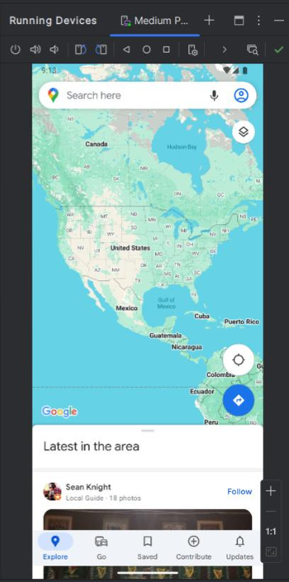

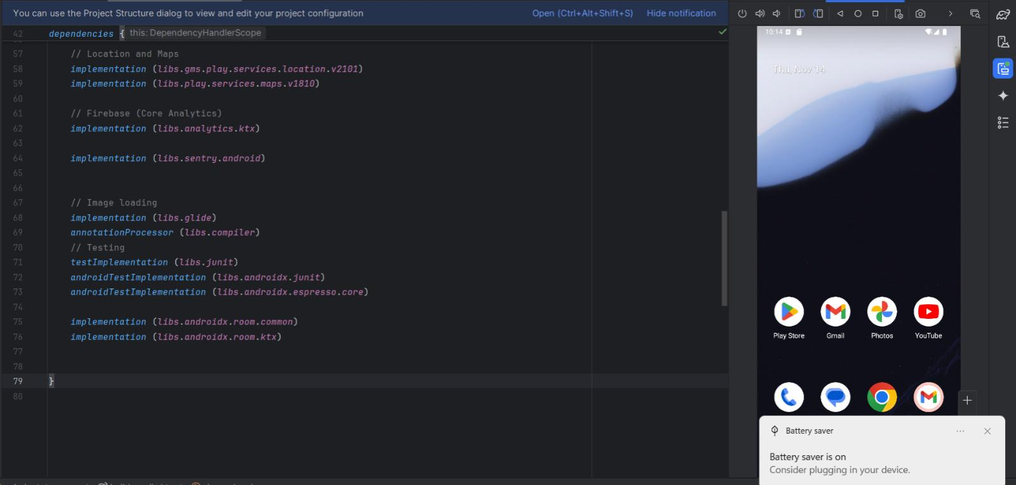

**Conclusion**

Wanderlust is designed to be a comprehensive travel companion, offering a personalized, user-friendly experience that supports travelers in planning, organizing, and enhancing their journeys. With features like itinerary management, budget tracking, real-time updates, and tailored recommendations, Wanderlust addresses the common challenges of travel, simplifying the process from start to finish.Through dedicated user testing, we have refined the app to meet user needs, integrating feedback to enhance functionality, speed, and ease of use. Looking ahead, we plan to expand with new features like AI-powered recommendations, immersive AR previews, and more offline tools to serve a diverse, global user base. By continuously improving and adapting to travel trends, Wanderlust aims to be the go-to app for travelers seeking a seamless, enjoyable, and customized travel experience.